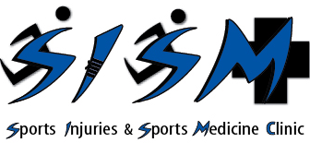
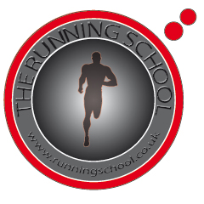
The Running School

and

The Sports Injuries and Sports Medicine Clinic

Running technique increasing performance, developeing speed and reducing injuires.

FORMER CHELSEA SPEED COACH, MIKE ANTIONADES TO OPEN RUNNING SCHOOL AT SPORTS INJURIES AND SPORTS MEDICINE CLNIC , CASTLEBAR.

Workshop : Running technique increasing performance, developing speed reducing injuries.
Presenters :Mike Antionades and Martin Mc Intyre.
Time and Date : Tuesday 28th of June from 9-11
Venue : The Running School at the Sports Injuries and Sports Medicine Clinic, Unit 5c, N5 Business Park, Castlebar, Co. Mayo.
Price : Free
Attendees: Places are limited so please ring to confirm attendance (086) 8139266.

Mike Antionades is the founder and Coaching Director of Sport Dimensions a London based company specializing in Performance & Rehabilitation Training and has worked with Chelsea FC, Chelsea Academy, Arsenal, Christine Ohuruogu (track) , Peter Reid (rowing), Emma Anya (track), Ollie Barclay (Rugby), ), Eidur Gudjhonsen (football), Tim Henman (tennis).
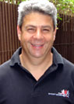

Martin Mc Intyre is the founder of the Sports Injuries and Sports Medicine Clinic has a MSc Sports Injury (Medicine); MSc Gaelic football; BSc(Hons) Sports Science; H.Dip Science and Football. He has 10 years experience in the field and has worked with Kerry Senior/ U21/ Minor teams the Roscommon minor team (2006-2008) and currently works with the Roscommon senior team.

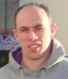

INVITATION
TO ADMIT ONE PERSON
Running technique : Increasing performance, reducing injuries and developing speed.
TIME AND DATE:

Workshop based on analyzing running technique to making athletes and sports people move quicker and faster, improve running technique and economy, reducing chronic overuse and persistent/recurring injuries and recovery from surgery.

